OUM
DS.140 Design Specification
RAYA
OFM-SOA-Implementation-
Integration Design

Author: Karunanidhi Natarajan
Creation Date: January 15, 2015
Last Updated: May 27, 2015
Document Ref: 1.0
Version: 1.0

Approvals:
Rafiq Lakhani
Osama AlDameri

Document Control

Change Record
4
Date | Author | Version | Change Reference
15-Jan-15 | Karunanidhi N | 1.0 | Initial or Draft Version

Reviewers

Name | Position
Rafiq Lakhani/Qambar Hasan | SBM Project Manager
Osama Al Dameri | EMAD Project Manager

Contents
1 Document Control 2
1.1 Change Record 2
1.2 Reviewers 2
2 Assumptions 6
3 Technical Overview 7
3.1 Building Blocks 7
3.2 Block Relationship Diagram 8
4 Integration Design for Purchase Order Creation 9
4.1 Business Rule Design 9
4.2 Integration Design - Quick Reference 9
4.3 Data Sources 10
4.4 Technical Design Information 11
4.5 Error Handling Considerations 12
4.6 Web Security Considerations 12
4.7 Performance Considerations 12
5 Integration Design for Purchase Order Creation Status 13
5.1 Business Rule Design 13
5.2 Integration Design - Quick Reference 13
5.3 Data Sources 14
5.4 Technical Design Information 15
5.5 Error Handling Considerations 16
5.6 Web Security Considerations 16
5.7 Performance Considerations 16
6 Integration Design for Contract Import 17
6.1 Business Rule Design 17
6.2 Integration Design - Quick Reference 17
6.3 Data Sources 18
6.4 Technical Design Information 19
6.5 Error Handling Considerations 21
6.6 Web Security Considerations 21
6.7 Performance Considerations 21
7 Integration Design for Contract Import Status 22
7.1 Business Rule Design 22
7.2 Integration Design - Quick Reference 22
7.3 Data Sources 23
7.4 Technical Design Information 24
7.5 Error Handling Considerations 25
7.6 Web Security Considerations 25
7.7 Performance Considerations 25
8 Integration Design for AR Invoice Creation 26
8.1 Business Rule Design 26
8.2 Integration Design - Quick Reference 26
8.3 Data Sources 27
8.4 Technical Design Information 28
8.5 Error Handling Considerations 29
8.6 Web Security Considerations 29
8.7 Performance Considerations 29
9 Integration Design for AR Invoice Creation Status 30
9.1 Business Rule Design 30
9.2 Integration Design - Quick Reference 30
9.3 Data Sources 31
9.4 Technical Design Information 31
9.5 Error Handling Considerations 32
9.6 Web Security Considerations 32
9.7 Performance Considerations 32
10 Integration Design to Check Contract billing Schedule in ebs 33
10.1 Business Rule Design 33
10.2 Integration Design - Quick Reference 33
10.3 Data Sources 34
10.4 Technical Design Information 35
10.5 Error Handling Considerations 35
10.6 Web Security Considerations 35
10.7 Performance Considerations 35
11 Integration Design to Check Customer Delinquency Status in ebs 36
11.1 Business Rule Design 36
11.2 Integration Design - Quick Reference 36
11.3 Data Sources 37
11.4 Technical Design Information 38
11.5 Error Handling Considerations 38
11.6 Web Security Considerations 38
11.7 Performance Considerations 38
12 Integration Design to Create Insurance for Vehicle in Third Party 39
12.1 Business Rule Design 39
12.2 Integration Design - Quick Reference 39
12.3 Data Sources 40
12.4 Technical Design Information 41
12.5 Error Handling Considerations 42
12.6 Web Security Considerations 42
12.7 Performance Considerations 42
13 Integration Design to Check Payment History of customer in ebs 43
13.1 Business Rule Design 43
13.2 Integration Design - Quick Reference 43
13.3 Data Sources 44
13.4 Technical Design Information 45
13.5 Error Handling Considerations 45
13.6 Web Security Considerations 45
13.7 Performance Considerations 46
14 Integration Design to Create AP Invoice and Goods Receipt in ebs 47
14.1 Business Rule Design 47
14.2 Integration Design - Quick Reference 47
14.3 Data Sources 48
14.4 Technical Design Information 49
14.5 Error Handling Considerations 49
14.6 Web Security Considerations 50
14.7 Performance Considerations 50
15 Integration Design For AP Invoice and Delivery Note Notification Status 51
15.1 Business Rule Design 51
15.2 Integration Design - Quick Reference 51
15.3 Data Sources 52
15.4 Technical Design Information 52
15.5 Error Handling Considerations 53
15.6 Web Security Considerations 53
15.7 Performance Considerations 53
16 Integration Design For AR Payment Notification Status 54
16.1 Business Rule Design 54
16.2 Integration Design - Quick Reference 54
16.3 Data Sources 55
16.4 Technical Design Information 56
16.5 Error Handling Considerations 57
16.6 Web Security Considerations 57
16.7 Performance Considerations 57
17 Integration Design For Simah Credit Check Process 58
17.1 Business Rule Design 58
17.2 Integration Design - Quick Reference 58
17.3 Data Sources 59
17.4 Technical Design Information 60
17.5 Error Handling Considerations 60
17.6 Web Security Considerations 61
17.7 Performance Considerations 61
18 Quality of Service Design Considerations 62
18.1 Crash Recovery 62
18.2 Security 62
18.3 Performance 62
19 Installation Considerations 63
20 Open and Closed Issues 64
20.1 Open Issues 64
20.2 Closed Issues 64

Assumptions
- SOA layer will be integrated to OLFM and SIEBEL and will be a prerequisite for data flows.
- SADAD Integration will have manual upload of Account creation and Bill Payments.
- OLFM and SIEBEL system should exists and the same is configured in Oracle Fusion Middleware-SOA to connect with each other via SOA integration adapters such as DB, APPS, FTP, File adapters and etc.
- Fault Handler Service should exist.
- Siebel outbound Notification Service exist and available to communicate.
- EBS Staging tables and Concurrent Programs available to Invoke and get the response as per the design.

Technical Overview
This Design Specification documents the detailed design for Oracle SOA Integration implementation that is part of OLFM and Siebel implementation This specification, the design specifications for the other components that are part of this use-case package (package), along with the Analysis Specification for the package constitute the complete detailed design for this use case package.

Building Blocks
The Component design includes several Integration as listed below:
- Custom Purchase Request Inbound Interface
- Custom Purchase Order Outbound Interface
- Custom Import Customers Inbound Interface
  - Custom Import Customers Inbound Interface for Retail Customers
  - Custom Import Customers Inbound Interface for Corporate Customers
- Custom Contract Import Inbound Interface
  - Custom Contract Import Inbound Interface for Retail Customers
  - Custom Contract Import Inbound Interface for Corporate Customers
- Custom Billing and Collections Outbound Interface
  - Invoice Amount, Due Amount, Due Date
  - Paid Amount, Instrument Number.
- Custom Outbound Interface For SADAD
- Custom Inbound Interface for SADAD
- Custom User hooks for Accounting

Building Blocks:
- Credit to Origination
- Invoice to Receipt
- Quote to Termination

Block Relationship Diagram
The process flow diagram explains the blocks and their relationships at the processes (Building blocks) level.
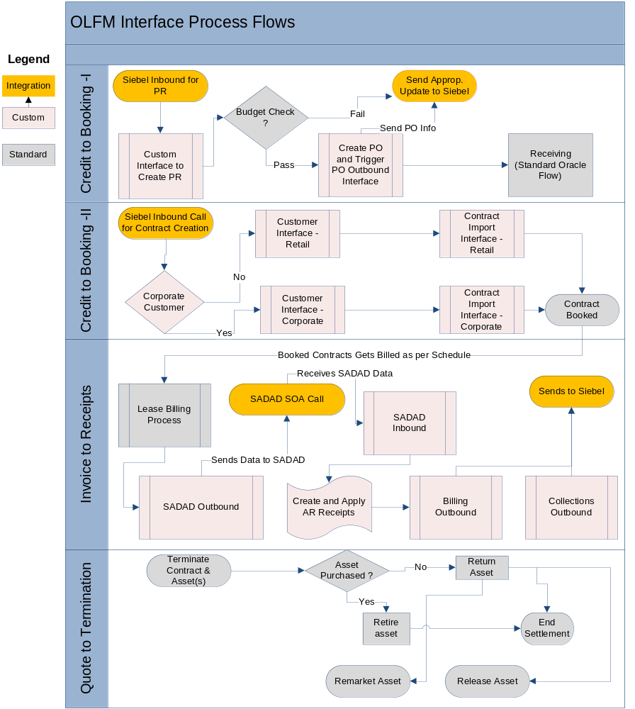

Integration Design for Purchase Order Creation
The Integration is to provide an automated PR for vehicle that needs to be procured by the client in the purpose of leasing it to the Lessee.

Business Rule Design
There would be a request coming from Source system along with PR data and the same would be processed as below.
1. Validate the following inputs for null check and validity checks:
- Vendor Name/Number.
- Contract Number
- PR Type
- Make and Model
- Policy number
- Cost
2. After validating, Insert the PR data to eBS staging table
3. Then invoke eBS PO creation concurrent Program to process the same. If there is any error in validation or system failure, the same will be communicated to source system.
4. Once the PO is created successfully, then notification is sent through "PurchaseOrderStatus" service.

Integration Design - Quick Reference
SOA Project Name | PurchaseOrderCreate
Source - Target System | Siebel - EBS
Inbound SOA Service Design | SOA WSDL Interface is derived from Siebel input and response schemas .XSD (attached in 4.3.1)
Outbound SOA Reference Design | EBS DB, APPS Adapter and Webservice
Frequency | On Demand
Volume
Interface Pattern | Synchronous

Data Sources

Request/Response Information
Type | Details
Request | 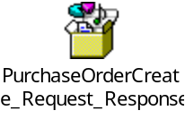
Response

Mapping Information
Request
SORUCE DATA ENTITY(SIEBEL) | REQUIRED | TARGET DATA ENTITY(EBS) | DEFAULT VALUE | COMMENTS
UserName | Y | UserName
OrgId | Y | OrgId
RespName | Y | RespName
InterfaceStageId |  | InterfaceStageId
InterfaceCode |  | InterfaceCode
InterfaceStatusCode |  | InterfaceStatusCode
RequestId | Y | RequestId
Cost | Y | Cost
OracleVendorName |  | OracleVendorName
PRType | Y | PRType
Quantity |  | Quantity
ContractNumber | Y | ContractNumber
VinNumber | Y | VinNumber
Make | Y | Make
Model | Y | Model
AgencyName |  | AgencyName
CreatedBy |  | CreatedBy
CreationDate |  | CreationDate
LastUpdateBy |  | LastUpdateBy
LastUpdateDate |  | LastUpdateDate
LastUpdateLogin |  | LastUpdateLogin
Commision |  | Commision
Discount |  | Discount

Response
SORUCE DATA ENTITY(EBS) | REQUIRED | TARGET DATA ENTITY(Siebel) | DEFAULT VALUE | COMMENTS
RequestID | Y | Request_Id
ReturnStatus | Y | StatusCode
 | Y | ResponseDateTime | xp20:current-date()

Technical Design Information

Composite Diagram
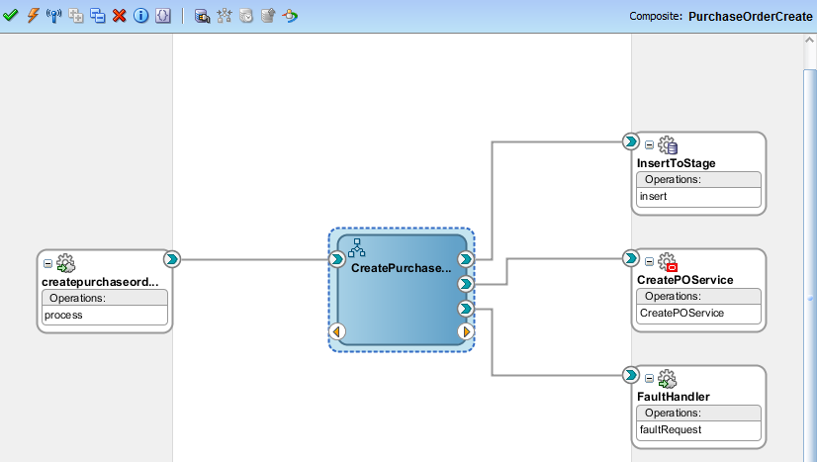

Technical Program Flow
- Get Input Payload from Siebel
- Pass it to BPEL Receive activity
- Validate the NULL check for mandatory fields such as contract number, vendor number, PR type, make, model and policy number
- IF all validation is passed
a) Map the data as per section 4.3.1 and Insert the data into eBS Staging table: XXAMG_RY_PR_STG_T through DB Adapter
b) Invoke PO creation concurrent program: XXAMG_RY_PR_INB through APPS Adapter and Send the response to Siebel as "Concurrent Program Initiated Successfully" If successful, Otherwise return the response with appropriate Error Message.
ELSE
Send the Error status and error message as a response to Siebel.
END IF;

Error Handling Considerations
AMG Standard Fault Handler Service is used to capture all system related failure/error information.

Web Security Considerations
There is no security required as this service is integrated within application modules and act as Internal Web service.

Performance Considerations
As per standard Oracle SOA Integration.

Integration Design for Purchase Order Creation Status
The Integration is to provide an automated PO for vehicle that was procured by the client in the purpose of leasing it to the Lessees.

Business Rule Design
1. A Business event will be raised from Oracle EBS once the PO processing is done.
2. The above business event will be having the no. Of PO is processed.
3. Get the status, PO details of each PO and send it to Siebel.

Integration Design - Quick Reference
SOA Project Name | PurchaseOrderStatus
Source - Target System | EBS - Siebel
Inbound SOA Service Design | EBS Business Event (attached in 5.3.1)
Outbound SOA Reference Design | EBS DB Adapter and Siebel Web service
Frequency | Scheduled or Ondemand
Volume
Interface Pattern | One-way

Data Sources

Request/Response information
Type | Details
Request | "xxamg.oracle.apps.okl.RayahPOReqErrEvent" ( Ebs Business event)
Response(Internal) | 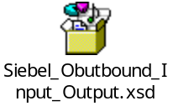

Mapping Information
Request
SORUCE DATA ENTITY(EBS) | REQUIRED | TARGET DATA ENTITY(SIEBEL) | DEFAULT VALUE | COMMENTS
PRType |  | ATTRIB1
Contract_Number |  | Contract_number
Soa_rqst_id |  | SR_REQ_ID
 |  | Interface_code | 'XXAMG_RY_PURCH_PKG'
Status | Y | Interface_Status_Code
Err_msg |  | ERROR_MSG
 |  | Notification_Type | 'PO_Request_Status'
Response
SORUCE DATA ENTITY(Siebel Response) | REQUIRED | TARGET DATA ENTITY(EBS Stg Table: XXAMG_RY_SOA_OUT_STATUS) | DEFAULT VALUE | COMMENTS
Contract_Number |  | Contract_number
SOA_RQST_ID |  | SOA_RQST_ID
 |  | Interface_code | 'XXAMG_RY_PURCH_PKG'
Siebel_return_Code | Y | STATUS_CODE
Siebel_return_code_desc |  | STATUS_CODE_DESC
 |  | Notification_Type | 'PO_Request_Status'

Technical Design Information

Composite Diagram
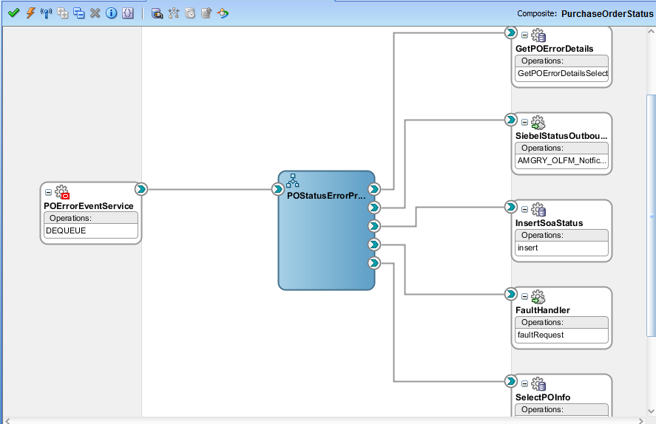

Technical Program Flow
- Capture the eBS Business event: xxamg.oracle.apps.okl.RayahPOReqErrEvent
- Loop through the SOA request ID and Status for each Request
- Check the Status parameter and Get the PO details from eBS Staging table: XXAMG_RY_PR_STG_T through DB Adapter, Otherwise get the error details from eBS Staging table: XXAMG_RY_ERR_STG_T
- Derive Siebel Outbound access details from SiebelOutboundNotifyCredentials.dvm which is in MDS and assign it to Input header variable for Siebel outbound notification service.
- Pass the above details to Siebel Outbound service.
- Get the response from Siebel outbound service and insert the SOAStatus to eBS Staging table: XXAMG_RY_SOA_OUT_STATUS through DB Adapter

Error Handling Considerations
AMG Standard Fault Handler Service is used to capture all system related failure/error information.

Web Security Considerations
While Invoking the Siebel outbound Service, pass userName, passWord and SessionType in Header Section of Invoke Activity
The Header Variable contains the record type : userName, passWord, SessionType.

Performance Considerations
As per standard Oracle SOA Integration.

Integration Design for Contract Import
The Integration is to provide an automated capital lease contract Import in Oracle ERP when there is a close complete of a Siebel Opportunity.

Business Rule Design
- The SOA Layer which listens to the Siebel Close Complete of the opportunity and performs the data load into custom stage tables as per the mapping provided.
- Validate the Contract, Asset and Schedule data.
- If the validations fail, Mark error and end the Integration Else go to the next step.
- Derive and populate the standard OLFM Integration tables for contract import.
- Invoke the Lease Open Integration
- Wait for flow to complete the Lease Open Integration.
- End the Integration.

Integration Design - Quick Reference
SOA Project Name | CreateContract
Source - Target System | Siebel - EBS
Inbound SOA Service Design | Siebel Input Payload
Outbound SOA Reference Design | EBS DB Adapter and Apps Adapter
Frequency | Scheduled or Ondemand
Volume
Interface Pattern | Synchronous

Data Sources

Request/Response information
Type | Details
Request | 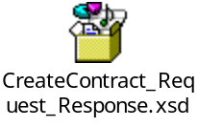
Response

Mapping Information
Request
The input payload field are mapped to ebs Staging table such as XXAMG_RY_CON_H_STG_T, XXAMG_RY_CON_L_STG_T, XXAMG_RY_CUST_STG_T

Response
SORUCE DATA ENTITY(EBS) | REQUIRED | TARGET DATA ENTITY(Siebel) | DEFAULT VALUE | COMMENTS
RequestID | Y | Request_Id
ReturnStatus | Y | StatusCode
 | Y | ResponseDateTime | xp20:current-date()

Technical Design Information

Composite Diagram
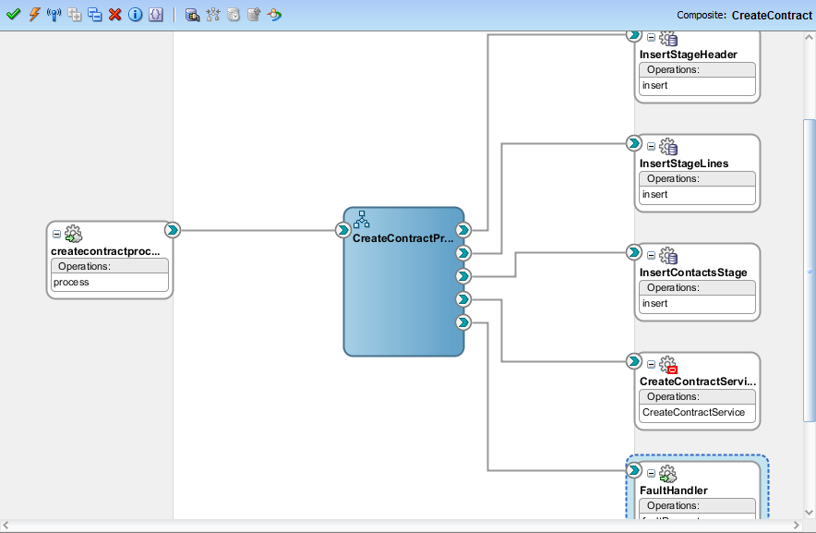

Technical Program Flow
1) Receive the Payload data throguh BPEL Receive activity.
2) The following fields have to be checked for being not null.
- CUSTOMER_ID
- GUARANTOR_ID
- TOTAL_COST
- TERM
- INTREST_PERCENT
- INSURANCE_PERCENT
- DOWNPAYMENT_PERCENT
- ADMIN_FEE_PERCENT
- BALLOON_PAYMENT_PERCENT
- CONTRACT_SIGNED_DATE
- BALLOON_PAYMENT_AMOUNT
- PARENT_FINANCE_ACCOUNT_ID
- FINANCE_ACCOUNT_ID
- MAKE
- MODEL
- MANUFACTURER
- ASSET_COST
- ASSET_NUMBER_SIEBEL
- VIN_NUMBER
- AGENCY_NAME
- ORACLE_VENDOR_NAME
- PO_NUMBER
- PARENT_FINANCE_ACCOUNT_ID
- MONTH_NUMBER
- FINANCE_ACCOUNT_ID
- ASSET_NUMBER_SIEBEL
- SCHEDULE_DATE
- AMOUNT

- After validation, put the data into Contract Header, Line and Contact Staging tables such as XXAMG_RY_CON_H_STG_T, XXAMG_RY_CON_L_STG_T, XXAMG_RY_CUST_STG_T
- Invoke ebs concurrent program: XXAMG_RY_CON_INB to process the contracts.
- Reply to Siebel with status and error message..

Error Handling Considerations
AMG Standard Fault Handler Service is used to capture all system related failure/error information.

Web Security Considerations
There is no security required as this service is integrated within application modules and act as Internal Web service.

Performance Considerations
As per standard Oracle SOA Integration.

Integration Design for Contract Import Status
The Integration is to provide an automated status to Siebel When contract import is done by EBS for requested contract from Siebel.

Business Rule Design
1. A business event is raised from Oracle ebs which will be captured by SOA along with SOA Request ID
2. Using SOA Request Id, Get all contract details and it's status.
3. Send the status of contract import to Siebel.

Integration Design - Quick Reference
SOA Project Name | CreateContractStatus
Source - Target System | EBS - Siebel.
Inbound SOA Service Design | EBS Business event
Outbound SOA Reference Design | EBS DB Adapter and Apps Adapter, Siebel Outbound Notification Service
Frequency | Scheduled or Ondemand
Volume
Interface Pattern | One-way

Data Sources

Request/Response information
Type | Details
Request | xxamg.apps.oracle.ConSuccEvent

Mapping Information
eBS-Siebel Mapping
SORUCE DATA ENTITY(EBS) | REQUIRED | TARGET DATA ENTITY(Siebel) | DEFAULT VALUE | COMMENTS
contractNumber |  | CONTRACT_NUMBER
'Contract_Import_Status' |  | NOTIFICATION_TYPE
'XXAMG_RY_CON_INB' |  | INTERFACE_CODE
 |  | INTERFACE_STATUS_CODE |  | Based on Sucess('0)' or error('2')
soaRqstId |  | SR_REQ_ID
 |  | ATTRIB1 |  | Contract Status

Technical Design Information

Composite Diagram
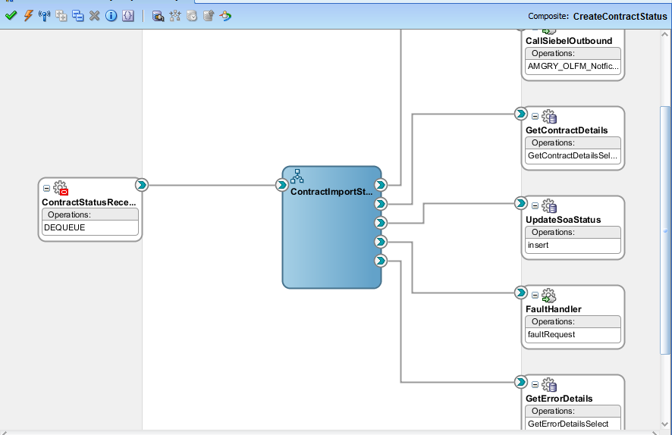

Technical Program Flow
1) Receive Input data through eBS Business Event.
2) Pass SOA_Request ID and Status
3) If Status is Success, then get the details from Success Staging table: XXAMG_RY_CON_H_STG_T, else get the error details from ebs Staging table: XXAMG_RY_ERR_STG_T
Derive Siebel Outbound access details from SiebelOutboundNotifyCredentials.dvm which is in MDS and assign it to Input header variable for Siebel outbound notification service.
4) Invoke Siebel outbound notification service by passing the above values and get the response
5) Insert the Siebel response in ebs Staging table: XXAMG_RY_SOA_OUT_STATUS

Error Handling Considerations
AMG Standard Fault Handler Service is used to capture all system related failure/error information.

Web Security Considerations
While Invoking the Siebel outbound Service, pass userName, passWord and SessionType in Header Section of Invoke Activity
The Header Variable contains the record type : userName, passWord, SessionType.

Performance Considerations
As per standard Oracle SOA Integration.

Integration Design for AR Invoice Creation
The Integration is to provide an automated AR Invoice Import in Oracle ERP from Siebel.

Business Rule Design
- Receive the Invoice payload from Siebel
- Validate the required fields which are required for ebs to create the invoice like contract number, invoice type, amount,product type and sadad number(detailed in Technical Flow)
- On successful validation, Put the data into ebs staging table.
- Invoke EBS AR Invoice creation program
- Reply to Siebel with response.

Integration Design - Quick Reference
SOA Project Name | CreateInvoice
Source - Target System | Siebel - EBS
Inbound SOA Service Design | Siebel Input Payload
Outbound SOA Reference Design | EBS DB Adapter and Apps Adapter
Frequency | Scheduled or Ondemand
Volume
Interface Pattern | Synchronous

Data Sources

Request/Response information
Type | Details
Request | 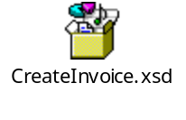
Response

Mapping Information
Request
SORUCE DATA ENTITY(Siebel) | REQUIRED | TARGET DATA ENTITY: XXAMG_RY_AUTO_INV_STG_T (EBS) | DEFAULT VALUE | COMMENTS
UserName | Y
InterfaceCode | Y
InterfaceStatusCode | Y
TaxPayerId | Y
RequestId | Y | Soa_req_ID
CreatedBy | Y | createdBy
SADADRefNum | Y | sadadRefNumber
ProductType | Y | ProductType
OrgID | Y | OrgID
Respname | Y | RespName
ContractNumber | Y | ContractNumber
DownPayment/AdminFeePayment | Y | Amount

Response
SORUCE DATA ENTITY(EBS Response) | REQUIRED | TARGET DATA ENTITY | DEFAULT VALUE | COMMENTS
RequestId | Y | RequestId
ContractNumber | Y | ContractNumber
StatusCode | Y | StatusCode
StatusDesc | Y | StatusDesc
ResponseDateTime | Y | ResponseDateTime

Technical Design Information

Composite Diagram
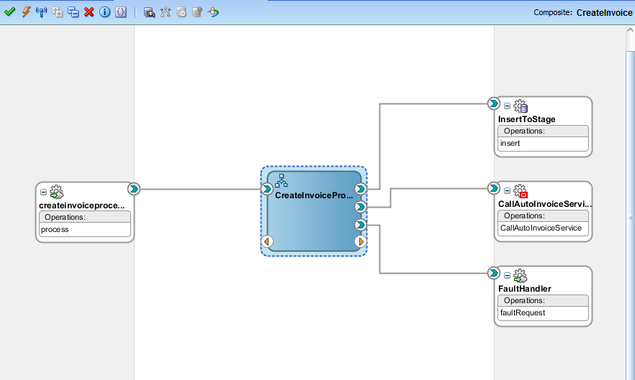

Technical Program Flow
1) Receive the Invoice Payload data throguh BPEL Receive activity.
2) The following fields have to be checked for being not null.
- Tax Payer Id
- Product Type
- Contract Number
- Sadad Ref number
- Invoice type

- Based on the invoice type(Adhoc, DownPayment,Admin Fee), get the respective amount.
- Insert the invoice details to ebs Staging table : XXAMG_RY_AUTO_INV_STG_T
- Invoke ebs concurrent program: XXAMG_RY_AUTO_INVOICE_PKG:Process to process the invoice.
- Reply to Siebel with status and error message..

Error Handling Considerations
AMG Standard Fault Handler Service is used to capture all system related failure/error information.

Web Security Considerations
There is no security required as this service is integrated within application modules and act as Internal Web service.

Performance Considerations
As per standard Oracle SOA Integration.

Integration Design for AR Invoice Creation Status
The Integration is to provide an automated status to Siebel When AR Invoice import is done by EBS for requested Invoice from Siebel.

Business Rule Design
1. A business event is raised from Oracle ebs which will be captured by SOA along with SOA Request ID
2. Using SOA Request Id, Get all Invoice details and it's status.
3. Send the status of Invoice import to Siebel.

Integration Design - Quick Reference
SOA Project Name | CreateInvoiceStatus
Source - Target System | EBS - Siebel.
Inbound SOA Service Design | EBS Business event
Outbound SOA Reference Design | EBS DB Adapter and Apps Adapter, Siebel Service
Frequency | Scheduled or Ondemand
Volume
Interface Pattern | One-way

Data Sources

Request/Response information
Type | Details
Request | xxamg.oracle.apps.okl.InvSuccEvent

Mapping Information

Technical Design Information

Composite Diagram
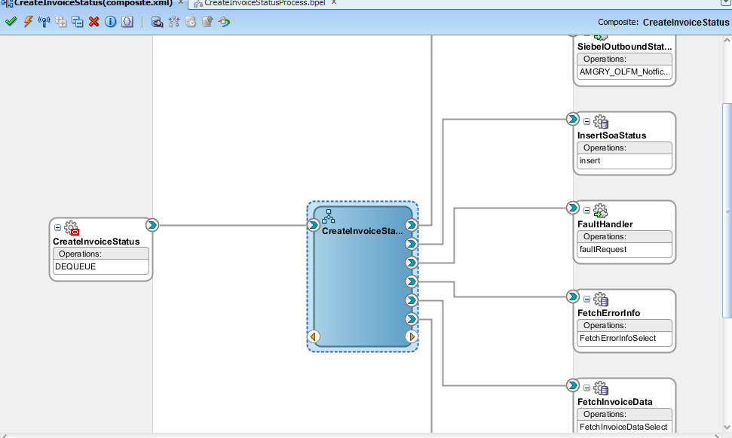

Technical Program Flow
- Receive the E-Business event from EBS along with SOA Request ID which was processed by the CreateInvoice inbound process.
- Fetch the Invoice and it's status from ebs staging table: XXAMG_RY_AUTO_INV_STG_T using SOA Request ID.
- If Invoices Status is error, then get the error details from Error Staging table: XXAMG_RY_ERR_STG_T
- Otherwise get the invoice details
- Derive Siebel Outbound access details from SiebelOutboundNotifyCredentials.dvm which is in MDS and assign it to Input header variable for Siebel outbound notification service.
- Pass it to Siebel outbound and get the response
- Record the response in SOA Staging table: XXAMG_RY_SOA_OUT_STATUS for tracking purpose

Error Handling Considerations
AMG Standard Fault Handler Service is used to capture all system related failure/error information.

Web Security Considerations
While Invoking the Siebel outbound Service, pass userName, passWord and SessionType in Header Section of Invoke Activity
The Header Variable contains the record type : userName, passWord, SessionType.

Performance Considerations
As per standard Oracle SOA Integration.

Integration Design to Check Contract billing Schedule in ebs
The Integration is to get the billing schedule of contract from ebs to Siebe. Siebel will pass customer and contract number as input to get the same.

Business Rule Design
- Receive the input from Siebel . The input parameters are customer, contract number and soa request
- Get Billing Schedule from ebs for the contract and customer.
- Reply to Siebel with billing schedule status.

Integration Design - Quick Reference
SOA Project Name | BillingScheduleInterface
Source - Target System | Siebel - EBS
Inbound SOA Service Design | Siebel Input Payload
Outbound SOA Reference Design | EBS DB Adapter
Frequency | Scheduled or Ondemand
Volume
Interface Pattern | Synchronous

Data Sources

Request/Response information
Type | Details
Request | 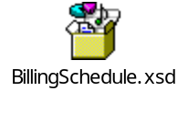
Response

Mapping Information
Request
SORUCE DATA ENTITY(Siebel) | REQUIRED | TARGET DATA ENTITY(EBS) | DEFAULT VALUE | COMMENTS
SOA Request Id | Y
Customer ID | Y | XXAMG_RY_CON_BILL_SCH_V. customer_ID
Contract Number | Y | XXAMG_RY_CON_BILL_SCH_V.Contract_Number
Response
SORUCE DATA ENTITY(EBS Response) | REQUIRED | TARGET DATA ENTITY | DEFAULT VALUE | COMMENTS
RequestId | Y | RequestId
ContractNumber | Y | ContractNumber
StatusCode | Y | StatusCode
StatusDesc | Y | StatusDesc
ResponseDateTime | Y | ResponseDateTime

Technical Design Information

Composite Diagram
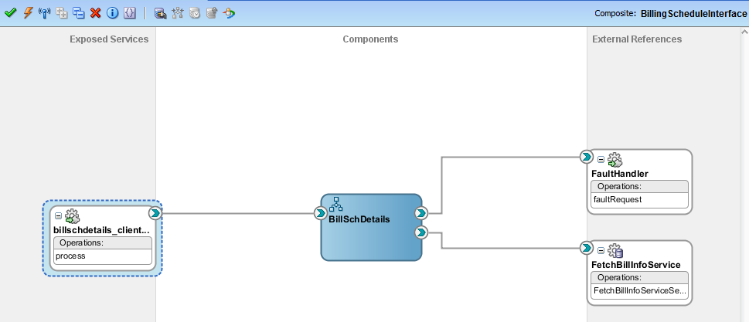

Technical Program Flow
1) Receive the Invoice Payload data throguh BPEL Receive activity.
2) Pass the Customer number and Contract Number to DB Adapter and get the billing schedule from ebs view: XXAMG_RY_CON_BILL_SCH_V.
3) Reply to Siebel with Billing Schedule of the contract.

Error Handling Considerations
AMG Standard Fault Handler Service is used to capture all system related failure/error information.

Web Security Considerations
There is no security required as this service is integrated within application modules and act as Internal Web service.

Performance Considerations
As per standard Oracle SOA Integration.

Integration Design to Check Customer Delinquency Status in ebs
The Integration is to get the delinquency status of customer from ebs to Siebel.

Business Rule Design
- Receive the customer as input from Siebel .
- Call EBS function to get delinquency status and amount by passing the customer id.
- Reply to Siebel with status and amount.

Integration Design - Quick Reference
SOA Project Name | CheckDelinquencyStatus
Source - Target System | Siebel - EBS
Inbound SOA Service Design | Siebel Input Payload
Outbound SOA Reference Design | EBS DB Adapter
Frequency | Scheduled or Ondemand
Volume
Interface Pattern | Synchronous

Data Sources

Request/Response information
Type | Details
Request | 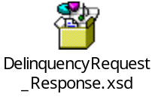
Response

Mapping Information
Request
SORUCE DATA ENTITY(Siebel) | REQUIRED | TARGET DATA ENTITY(EBS) | DEFAULT VALUE | COMMENTS
Customer ID | Y | XXAMG_RY_BILL_PAY_PKG:GET_DELINQUENCY_STATUS(customer_ID)
Response
SORUCE DATA ENTITY(EBS Response) | REQUIRED | TARGET DATA ENTITY(Siebel) | DEFAULT VALUE | COMMENTS
Del_Status | Y | Status
Del_Amount | Y | Amount

Technical Design Information

Composite Diagram
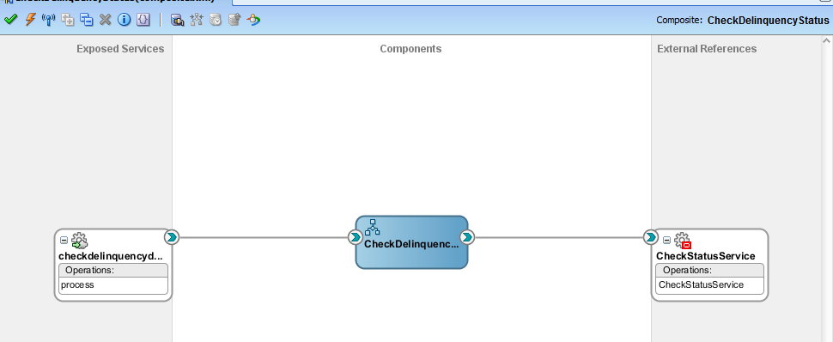

Technical Program Flow
1) Receive the Invoice Payload data through BPEL Receive activity.
2) Customer ID should not be null. Pass the customer id to eBS XXAMG_RY_BILL_PAY_PKG:GET_DELINQUENCY_STATUS and get the Status and amount
3) Reply to Siebel with Delinquency Status and amount to Siebel.

Error Handling Considerations
AMG Standard Fault Handler Service is used to capture all system related failure/error information.

Web Security Considerations
There is no security required as this service is integrated within application modules and act as Internal Web service.

Performance Considerations
As per standard Oracle SOA Integration.

Integration Design to Create Insurance for Vehicle in Third Party
The Integration is to create a third party insurance for vehicle

Business Rule Design
- Receive the input from Siebel .
- Invoke Third party web service to send the XML payload
- Reply to Siebel.

Integration Design - Quick Reference
SOA Project Name | CreateInsuranceInterface
Source - Target System | Siebel - Thirdparty
Inbound SOA Service Design | Siebel Input Payload
Outbound SOA Reference Design | Webservice (http://77.240.88.22/EliteWCF/UploadMotor.svc)
Frequency | Scheduled or Ondemand
Volume
Interface Pattern | Synchronous

Data Sources

Request/Response information
Type | Details
Request | 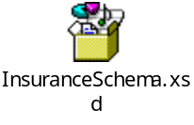
Response

Mapping Information
Request
SORUCE DATA ENTITY(Siebel) | REQUIRED | TARGET DATA ENTITY(Third Party WebService- http://77.240.88.22/EliteWCF/UploadMotor.svc | DEFAULT VALUE |  | COMMENTS
USERID | Y | USERID
PASSWORD | Y | PASSWORD
MOTORDATA |  | MOTORDATA
MCAR_DEDUCT_MIN |  | MCAR_DEDUCT_MIN
MCAR_DEDUCT_PERC |  | MCAR_DEDUCT_PERC
MCAR_EFFDATE |  | MCAR_EFFDATE
MCAR_ENGINENo |  | MCAR_ENGINENo
MCAR_EXPDATE |  | MCAR_EXPDATE
MCAR_FATHERNAME |  | MCAR_FATHERNAME
MCAR_FIRSTNAME |  | MCAR_FIRSTNAME
MCAR_GOVSEQNBR |  | MCAR_GOVSEQNBR
MCAR_HSPOWER |  | MCAR_HSPOWER
MCAR_IQAMAID |  | MCAR_IQAMAID
MCAR_LASTNAME |  | MCAR_LASTNAME
MCAR_MAKE |  | MCAR_MAKE
MCAR_MODEL |  | MCAR_MODEL
MCAR_NBPLACE |  | MCAR_NBPLACE
MCAR_OPERATION |  | MCAR_OPERATION
MCAR_PLATENo |  | MCAR_PLATENo
MCAR_POLNUM |  | MCAR_POLNUM
MCAR_PREMIUM |  | MCAR_PREMIUM
MCAR_REINS |  | MCAR_REINS
MCAR_REINSENDNUM |  | MCAR_REINSENDNUM
MCAR_REINSPOLNUM |  | MCAR_REINSPOLNUM
MCAR_REPAIR |  | MCAR_REPAIR
MCAR_REQSEQNO |  | MCAR_REQSEQNO
MCAR_SUMINS |  | MCAR_SUMINS
MCAR_USAGE |  | MCAR_USAGE
MCAR_YEAR |  | MCAR_YEAR
Response
SORUCE DATA ENTITY(ThirdParty Web service) | REQUIRED | TARGET DATA ENTITY(Siebel) | DEFAULT VALUE | COMMENTS
StatusDetails |  | StatusDetails

Technical Design Information

Composite Diagram
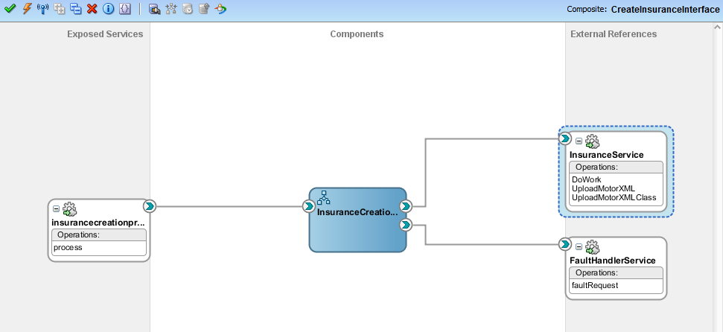

Technical Program Flow
1) Receive the Invoice Payload data through BPEL Receive activity.
2) Assign the payload data to Thirdparty webservice Fields.
3) Reply to Siebel with Status details

Error Handling Considerations
AMG Standard Fault Handler Service is used to capture all system related failure/error information.

Web Security Considerations
There is no security required as this service is integrated within application modules and act as Internal Web service.

Performance Considerations
As per standard Oracle SOA Integration.

Integration Design to Check Payment History of customer in ebs
The Integration is to get payment history of customer

Business Rule Design
- Receive the Customer and Contract Number as input from Siebel .
- Call EBS package to get Payment details such as Payament Status, Receipt Number, Invoice number, amount, payment date and payment channel.
- Reply to Siebel with above payment details

Integration Design - Quick Reference
SOA Project Name | PaymentHistory
Source - Target System | Siebel - EBS
Inbound SOA Service Design | Siebel Input Payload
Outbound SOA Reference Design | EBS DB Adapter
Frequency | Scheduled or Ondemand
Volume
Interface Pattern | Synchronous

Data Sources

Request/Response information
Type | Details
Request | 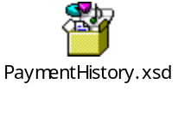
Response

Mapping Information
Request
SORUCE DATA ENTITY(Siebel) | REQUIRED | TARGET DATA ENTITY(EBS) | DEFAULT VALUE | COMMENTS
SOA_Request_ID | Y | XXAMG_RY_OLFM_PAY_DTL_V
CustomerID | Y | XXAMG_RY_OLFM_PAY_DTL_V.Customer_ID
ContractNumber | Y | XXAMG_RY_OLFM_PAY_DTL_V. Contract_number
Response
SORUCE DATA ENTITY: XXAMG_RY_OLFM_PAY_DTL_V (EBS Response) | REQUIRED | TARGET DATA ENTITY(Siebel) | DEFAULT VALUE | COMMENTS
SoaRqstId |  | SoaRqstId
CustomerId |  | CustomerId
ContractNumber |  | ContractNumber
StatusCode |  | StatusCode
StatusDesc |  | StatusDesc
PaymentAmount |  | PaymentAmount
PaymentChannel |  | PaymentChannel
SR_REQ_ID |  | SR_REQ_ID
PaymentType |  | PaymentType
PaymentDate |  | PaymentDate |  | MM/DD/YYYY
PaymentStatus |  | PaymentStatus
ReceiptNumber |  | ReceiptNumber
InvoiceAmount |  | InvoiceAmount
InvoiceDate |  | InvoiceDate |  | MM/DD/YYYY

Technical Design Information

Composite Diagram
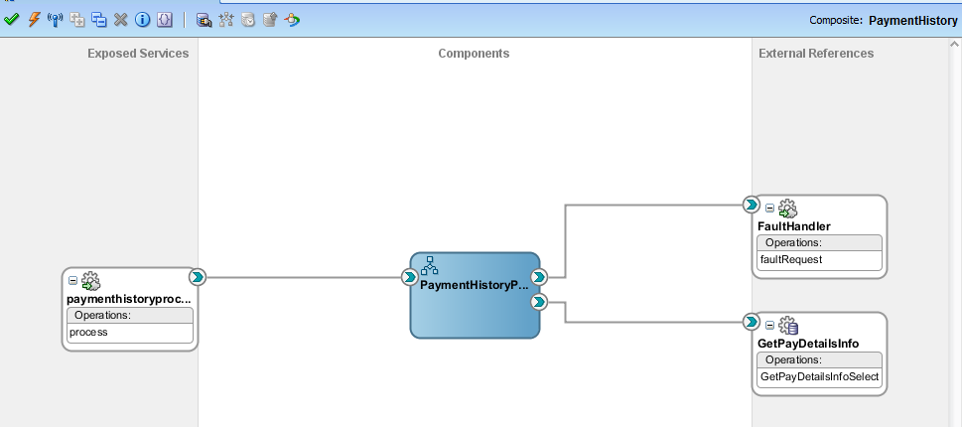

Technical Program Flow
1) Receive Payload data through BPEL Receive activity.
2) Pass customer and contract to EBS to get payment history
3) Reply to Siebel with payment history details

Error Handling Considerations
AMG Standard Fault Handler Service is used to capture all system related failure/error information.

Web Security Considerations
There is no security required as this service is integrated within application modules and act as Internal Web service.

Performance Considerations
As per standard Oracle SOA Integration.

Integration Design to Create AP Invoice and Goods Receipt in ebs
The Integration is to Create AP Invoice and Delivery details in EBS from Siebel

Business Rule Design
- Receive input from Siebel .
- Call EBS Adapters to insert the data into staging table and invoke a EBS concurrent program to create AP Invoice and Delivery Note
- Reply to Siebel about concurrent program submission Status

Integration Design - Quick Reference
SOA Project Name | ReceivingInterface
Source - Target System | Siebel - EBS
Inbound SOA Service Design | Siebel Input Payload
Outbound SOA Reference Design | EBS DB Adapter, APPS Adapter
Frequency | Scheduled or Ondemand
Volume
Interface Pattern | Synchronous

Data Sources

Request/Response information
Type | Details
Request | 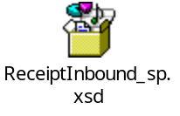
Response

Mapping Information
Request
SORUCE DATA ENTITY(Siebel) | REQUIRED | TARGET DATA ENTITY(EBS) | DEFAULT VALUE | COMMENTS
APPLICATION |  | XXAMG_RY_REC_STG_T
PROGRAM |  | XXAMG_RY_REC_STG_T,
DESCRIPTION |  | XXAMG_RY_REC_STG_T,
START_TIME |  | XXAMG_RY_REC_STG_T,
SUB_REQUEST |  | XXAMG_RY_REC_STG_T,
P_PO_NUMBER |  | XXAMG_RY_REC_STG_T.PO_NUMBER
P_SOA_RQST_ID |  | XXAMG_RY_REC_STG_T.SOA_REQUEST_ID
P_CONTRACT_NUMBER |  | XXAMG_RY_REC_STG_T.CONTRACT_NUMBER
Response
SORUCE DATA ENTITY (EBS Response) | REQUIRED | TARGET DATA ENTITY(Siebel) | DEFAULT VALUE | COMMENTS
REQUEST_ID |  | RequestID
RETURN_CODE |  | StatusCode
RETURN_MESSAGE |  | StatusDesc

Technical Design Information

Composite Diagram
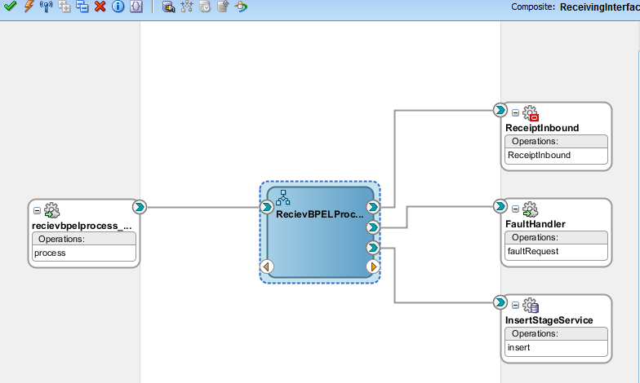

Technical Program Flow
1) Receive Payload data through BPEL Receive activity.
2) Validate Contract Number, PO Number and PR type are mandatory
3) If the above validation is passed, then insert into ebs Staging table: XXAMG_RY_REC_STG_T, otherwise call Fault handler service.
4) After Inserting data into eBS stage table, Invoke the eBS concurrent program: XXAMG_RY_RCPT_INB by passing user name and Responsibility of concurrent prorgram
The ebs Concurrent Program will process the data and put the status in success and error staging tables such as XXAMG_RY_REC_STG_T, XXAMG_RY_ERR_STG_T
5) Reply to Siebel with concurrent program submission status

Error Handling Considerations
AMG Standard Fault Handler Service is used to capture all system related failure/error information.

Web Security Considerations
There is no security required as this service is integrated within application modules and act as Internal Web service.

Performance Considerations
As per standard Oracle SOA Integration.

Integration Design For AP Invoice and Delivery Note Notification Status
The Integration is to send a Notification to Siebel When AP Invoice and Deliver Note is created

Business Rule Design
- Receive input from ebs Business event when Payment is made .
- Call EBS Adapters to fetch the data from EBS and send the details of Payment to Siebel.
- Then Siebel replies back to EBS about the notification is received success or Error

Integration Design - Quick Reference
SOA Project Name | PaymentNotificationProcess
Source - Target System | EBS-Siebel
Inbound SOA Service Design | EBS Business Event xxamg.apps.oracle.RecSuccEvent
Outbound SOA Reference Design | EBS DB Adapter, APPS Adapter ,Siebel Outbound Notification Service
Frequency | Scheduled or Ondemand
Volume
Interface Pattern | One-way

Data Sources

Request/Response information
Type | Details
Request | xxamg.apps.oracle.RecSuccEvent with SOA Request ID

Mapping Information
Note: Mapping is defined as per Siebel notification WSDL definition

Technical Design Information

Composite Diagram
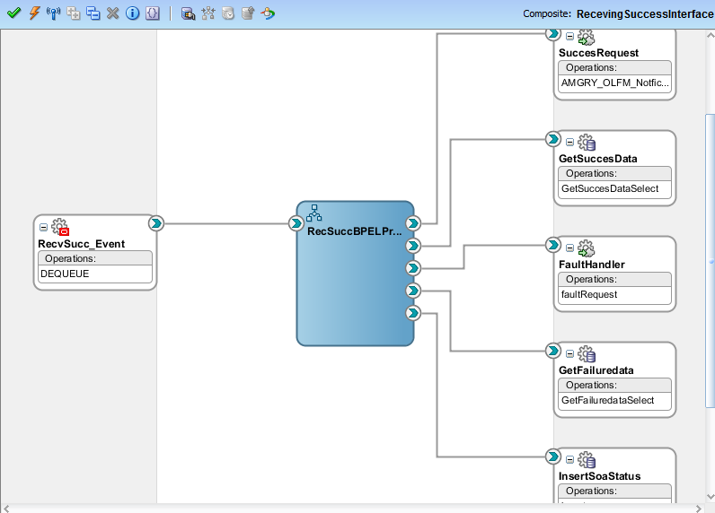

Technical Program Flow
1) Receive Input data through eBS Business Event.
2) Pass SOA_Request ID and Status
3) If Status is Success, then get the details from Success Staging table: XXAMG_RY_REC_STG_T, else get the error details from ebs Staging table: XXAMG_RY_ERR_STG_T.
- Derive Siebel Outbound access details from SiebelOutboundNotifyCredentials.dvm which is in MDS and assign it to Input header variable for Siebel outbound notification service.
4) Invoke Siebel outbound notification service by passing the above values and get the response
5) Insert the Siebel response in ebs Staging table: XXAMG_RY_SOA_OUT_STATUS

Error Handling Considerations
AMG Standard Fault Handler Service is used to capture all system related failure/error information.

Web Security Considerations
While Invoking the Siebel outbound Service, pass userName, passWord and SessionType in Header Section of Invoke Activity
The Header Variable contains the record type : userName, passWord, SessionType.

Performance Considerations
As per standard Oracle SOA Integration.

Integration Design For AR Payment Notification Status
The Integration is to send Payment Notification to Siebel When Payment is made against an AR Invoice

Business Rule Design
- Receive input from ebs Business event when Payment is made .
- Call EBS Adapters to fetch Receipt and Invoice details from EBS and send to Siebel.
- Then Siebel replies back to EBS about the notification is received success or Error

Integration Design - Quick Reference
SOA Project Name | PaymentNotificationProcess
Source - Target System | EBS-Siebel
Inbound SOA Service Design | EBS Business Event: xxamg.oracle.apps.okl.PaymentEvent
Outbound SOA Reference Design | EBS DB Adapter, APPS Adapter ,Siebel Outbound Notification Service
Frequency | Scheduled or Ondemand
Volume
Interface Pattern | One-way

Data Sources

Request/Response information
Type | Details
Request | xxamg.oracle.apps.okl.PaymentEvent with payment count and SOA Request ID

Mapping Information
Response
SORUCE DATA ENTITY(EBS) | REQUIRED | TARGET DATA ENTITY(EBS) | DEFAULT VALUE | COMMENTS
 |  | VIN_NUMBER
 |  | ATTRIB5
 |  | SR_REQ_ID
'PAYMENT_NOTIFICATION_STATUS' |  | NOTIFICATION_TYPE
TOTAL_DUE_AMOUNT |  | TOTAL_DUE_AMOUNT
OLDEST_PAYMENT_DUE_DATE |  | OLDEST_PAYMENT_DUE_DATE
PAYMENT_STATUS |  | PAYMENT_STATUS
 |  | INTERFACE_CODE
 |  | PO_NUMBER
PAYMENT_AMOUNT |  | PAYMENT_AMOUNT
NEXT_DUE_DATE |  | NEXT_DUE_DATE
 |  | ATTRIB2
PAYMENT_CHANNEL |  | PAYMENT_CHANNEL
INTERFACE_STATUS_CODE |  | INTERFACE_STATUS_CODE
GOODS_RECIEPT_NUMBER |  | GOODS_RECIEPT_NUMBER
 |  | ATTRIB3
INVOICED_AMOUNT |  | INVOICED_AMOUNT
INTERFACE_STAGE_ID |  | INTERFACE_STAGE_ID
ERROR_MSG |  | ERROR_MSG
PAYMENT_DATE |  | PAYMENT_DATE
CONTRACT_NUMBER |  | CONTRACT_NUMBER
AP_INVOICE_NUMBER |  | AP_INVOICE_NUMBER
 |  | ATTRIB4
PAYMENT_TYPE |  | PAYMENT_TYPE
ATTRIB1 |  | ATTRIB1
CURRENT_BALANCE |  | CURRENT_BALANCE
INVOICED_DATE |  | INVOICED_DATE

Technical Design Information
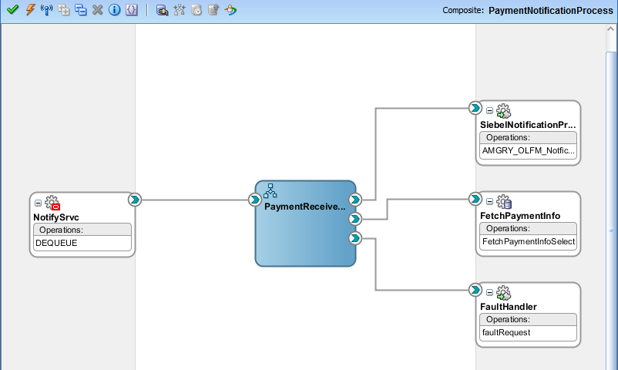

Technical Program Flow
1) Receive Input data through eBS Business Event.
2) Pass SOA_Request ID and Receipt Number to eBS to fetch payment details from XXAMG_RY_OLFM_PAY_DTL_V.
Derive Siebel Outbound access details from SiebelOutboundNotifyCredentials.dvm which is in MDS and assign it to Input header variable for Siebel outbound notification service.
3) Validate Payment type and assign the respective amount details to Siebel outbound Notification Service
IF payment Type is 'INS' and FEE , then pass Invoice Number, Contract Number, Receipt Number, Invoice Amount, Payment Amount, Payment date and Payment Type
End IF;
IF payment type is 'ADV' then, send Contract Number, total amount, Payment Type and Payment Channel
End if;

Error Handling Considerations
AMG Standard Fault Handler Service is used to capture all system related failure/error information.

Web Security Considerations
While Invoking the Siebel outbound Service, pass userName, passWord and SessionType in Header Section of Invoke Activity
The Header Variable contains the record type : userName, passWord, SessionType.

Performance Considerations
As per standard Oracle SOA Integration.

Integration Design For Simah Credit Check Process
The Integration is to get credit Score details of customer through SIMAH Interface

Business Rule Design
- Receive input from Siebel .
- Call Simah Interface to get Customer credit score details
- Reply back to Siebel with Credit Score details.

Integration Design - Quick Reference
SOA Project Name | SimahInterfaceProcess
Source - Target System | Siebel-Simah Iterface
Inbound SOA Service Design | Siebel Input Payload
Outbound SOA Reference Design | EBS DB Adapter
Frequency | Scheduled or Ondemand
Volume
Interface Pattern | Synchronous

Data Sources

Request/Response information
Type | Details
Request | 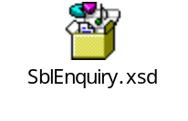
Response | 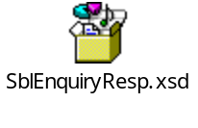

Mapping Information
Request and Response mapping fields are same for Simah interface except the access credentials.

Technical Design Information

Composite Diagram

Technical Program Flow
1) Receive Input data Siebel
2) Get the Simah Credentials from eBS DB Adapter through XXAMG_RY_SIMAH_PKG. GET_SIMAH_DETAILS. This package will return Simah URL, Username and Password.
Simah URL : https://consumerdev.simah.com/enquiry/inthttp.pgm
3) Perform a REST Service action using the HTTP Post utility or Java embedding to call the SIMAH interface
4) Get the response and reply to Siebel.

Error Handling Considerations
AMG Standard Fault Handler Service is used to capture all system related failure/error information.

Web Security Considerations
There is no security required as this service is integrated within application modules and act as Internal Web service.

Performance Considerations
As per Oracle SOA Integration standards.

Quality of Service Design Considerations
- As per EMAD Standards

Crash Recovery
- As per EMAD Standards

Security
- As per EMAD Standards

Performance
- As per EMAD Standards

Installation Considerations
Installation scripts must be prepared to perform the following actions in an automated way:
- .

Open and Closed Issues

Open Issues

ID | Issue | Resolution | Responsibility | Target Date | Impact Date

Closed Issues

ID | Issue | Resolution | Responsibility | Target Date | Impact Date

